Last month I was lucky enough to be featured on Rosie Amber’s Beach Reads Book Tour 2015 where we each got the chance to tell you about our ideal holiday destination and choose 5 books to take with us (you can click on the link to find out my choices). As I was due to go away to cool my toes very soon after the tour ended I pretty much listed out the books I was planning on taking with me and think it’s only sensible to follow up with their reviews plus a bit about my holiday destination which is one I find many people don’t know about.
Years ago when I worked in a proper office, was employed by others and had the luxury of lunch hours (and indeed holiday pay!)I’d make my way to the nearest travel agent, you will find I am all about the convenience, which was Lunn Poly populated by perky girls who always looked like they’d just got back from some sun drenched spot. This was well before spray tans came into existence and that look could only have been achieved by overindulgence on the sun bed and heavy use of bronzer. The perky girls always sported names such as Tina, Julie and Tricia - having at least one ‘i’ in their names seemed compulsorily just so they could add a little ‘o’ in lieu of a dot on the notes they sent us.
At some point I’d be beckoned to pick up our tickets and I remember how ridiculously excited I’d get at that point to be holding physical tickets and a bundle of luggage labels in my hand. These were the days where you still got meals on planes, however short the flight and even if it wasn’t a traditionally recognised mealtime, which to me was a bonus (loved all those little packets!) but on the downside I always anticipated at least a two hour delay for any flight we took - that was standard.
Nowadays printing out boarding passes doesn’t hold the same allure and somehow neither does travelling with today’s low budget airlines despite their ruthless efficiency and ability to stick to a schedule.
So, to Gozo, for this is my chosen holiday destination. I have no idea how I originally came upon it but we got off to a sticky start when we were let down by a BIG travel company who had double booked our villa and couldn’t replace it with anything remotely the same. I then came across MaltaChoice when trawling the internet who stepped into the breach and the rest, as they say, is history.
I have been incredibly busy the last few years and it has been all I can do to work out which week we can get away let alone research a holiday but now I have Paul of Maltachoice. I email him with my dates, he tells me what is available that week, I choose and he does the booking, sorts out transfers and books a car for me. I told you I was all about the convenience didn’t I! At some point we shall go elsewhere but for now this works.
So to tell you a little bit about Gozo with the help of Wikipedia. It is an island of the Maltese archipelago in the Mediterranean Sea. The island is part of the Southern European country of Malta. After the island of Malta itself, it is the second-largest island in the archipelago. Compared to its southeastern neighbour, Gozo is more rural and known for its scenic hills, which are featured on its coat of arms.^{[1]}
Courtesy of Visit Malta here is a map for you
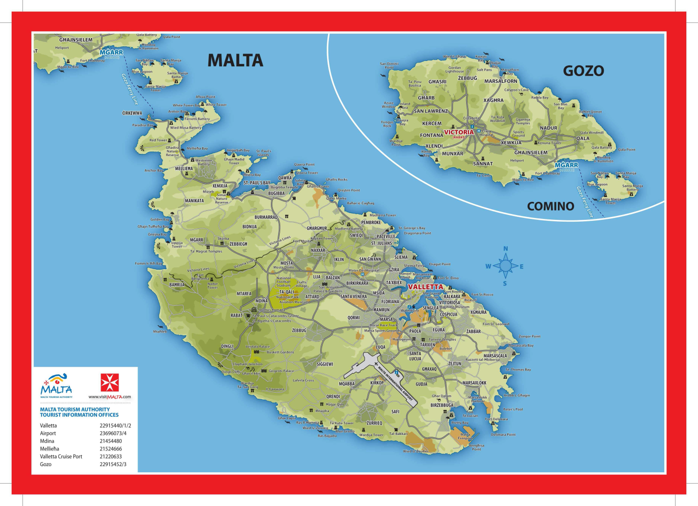
It covers 67 square kilometres (26 sq mi), approximately the same area as New York City's Manhattan island. It lies approximately 6 kilometres (4 mi) northwest of the nearest point of Malta, is of oval form, and is 14 kilometres (8.7 mi) long and 7.25 kilometres (4.50 mi) wide.
In order to get there you fly to Malta and then travel to the port (about 45 minutes) and then cross by ferry to Gozo which takes 25 minutes. If you ever fancy going a handy tip to note it that you don’t buy a ticket to get on the ferry from Malta you only buy one on your return journey.
This is the fourth year we have been coming here but we always stay somewhere different. As I go through this I shall attempt to give you the pronunciations but I apologise now to any Maltese speakers out there! We first stayed in Gharb (Arb) for which I have a particular fondness as it was there in 2012 whilst lying on a sun bed that the whole of the Grayson Trilogy was mapped out in my head. Then we went to Qala (Arla) then Xaghra (Schjarra) and this year we stayed in Sannat (Sannat! Gotcha!)
We travel early so are there by late lunchtime, after having to take a detour through Xewkija (Shokear) because the whole of the centre of Sannat is being block paved in readiness for the festival coming up - more later. Once we dump our bags we go in search of a shop which with it being in a residential area were all closed and we find ourselves walking through deserted streets that would have fitted in perfectly to the set of Westworld. Unable to find anything open due to siesta time the stuff we thought we’d get out here...like shower gel...rather than carry we can’t...lovely...
Still, giving up on our quest we crash out back at the farmhouse which has been built for giants (again, more on that later) and attempting to fit in with the siesta lifestyle I carry on with the first of my holiday reads, One Way Fare by Barb Taub and Hannah Taub (you can read my review here). But I fail in managing to have a nap, I’ve been up since 2.15am and I cannot switch off...
To be continued...

